製作Tomcat基本JSTL Tags
1. 使用JSTL 標籤必須在Tomcat Web應用程式外掛類別庫
C:\apache-tomcat-7.0.42\webapps\ROOT\WEB-INF新增 lib 資料夾
2. C:\apache-tomcat-7.0.42\webapps\ROOT\WEB-INF\lib 內加入 jstl.jar , standard.jar
3. C:\apache-tomcat-7.0.42\webapps\ROOT\ 內加入 JSTLif.jsp

<%@page contentType="text/html" pageEncoding="UTF-8"%>
<%@taglib uri="http://java.sun.com/jsp/jstl/core" prefix="c" %>
<!DOCTYPE html>
<html>
<head>
<meta http-equiv="Content-Type" content="text/html; charset=UTF-8">
<title>JSP Page</title>
</head>
<body>
<UL>
<c:forEach var="i" begin="1" end="10">
<li><c:out value="${i}"/>
<c:if test="${i > 7}">
(greater than 7)
</c:if>
</li>
</c:forEach>
</UL>
</body>
</html>

4. C:\apache-tomcat-7.0.42\webapps\ROOT\ 內加入 JSTLchoose.jsp
<%@page contentType="text/html" pageEncoding="UTF-8"%>
<%@taglib uri="http://java.sun.com/jsp/jstl/core" prefix="c" %>
<html>
<head>
<meta http-equiv="Content-Type" content="text/html; charset=UTF-8">
<title>JSP Page</title>
</head>
<body>
<h1>Hello World!</h1>
<c:forEach var="i" begin="1" end="10">
<LI><c:out value="${i}"/>
<c:choose>
<c:when test="${i < 4}">
(small)
</c:when>
<c:when test="${i < 8}">
(medium)
</c:when>
<c:otherwise>
(large)
</c:otherwise>
</c:choose>
</c:forEach>
</body>
</html>

5. C:\apache-tomcat-7.0.42\webapps\ROOT\ 內加入 JSTLToken.jsp
<%@page contentType="text/html" pageEncoding="UTF-8"%>
<%@taglib uri="http://java.sun.com/jsp/jstl/core" prefix="c" %>
<!DOCTYPE html>
<html>
<head>
<meta http-equiv="Content-Type" content="text/html; charset=UTF-8">
<title>JSP Page</title>
</head>
<body>
<h1>Hello World!</h1>
<UL>
<c:forTokens var="color"
items="(red (orange) yellow)(green)((blue) violet)"
delims="()">
<LI><c:out value="${color}"/>
</c:forTokens>
</UL>
</body>
</html>
6. C:\apache-tomcat-7.0.42\webapps\ROOT\ 內加入 JSTLArray.jsp
<%@page contentType="text/html" pageEncoding="UTF-8"%>
<%@taglib uri="http://java.sun.com/jsp/jstl/core" prefix="c" %>
<!DOCTYPE html>
<html>
<head>
<meta http-equiv="Content-Type" content="text/html; charset=UTF-8">
<title>JSP Page</title>
</head>
<body>
<h1>Hello World!</h1>
<% String[] words = {"foo", "bar", "baz"};
pageContext.setAttribute("words", words);%>
<H2>Key Words:</H2>
<UL>
<c:forEach var="word" items="${words}">
<LI><c:out value="${word}"/>
</c:forEach>
</UL>
<br/>
<h2>Country Array </h2>
<c:forEach
var="country"
items="Australia,Canada,Japan,Philippines,USA">
<LI><c:out value="${country}"/>
</c:forEach>
</body>
</html>
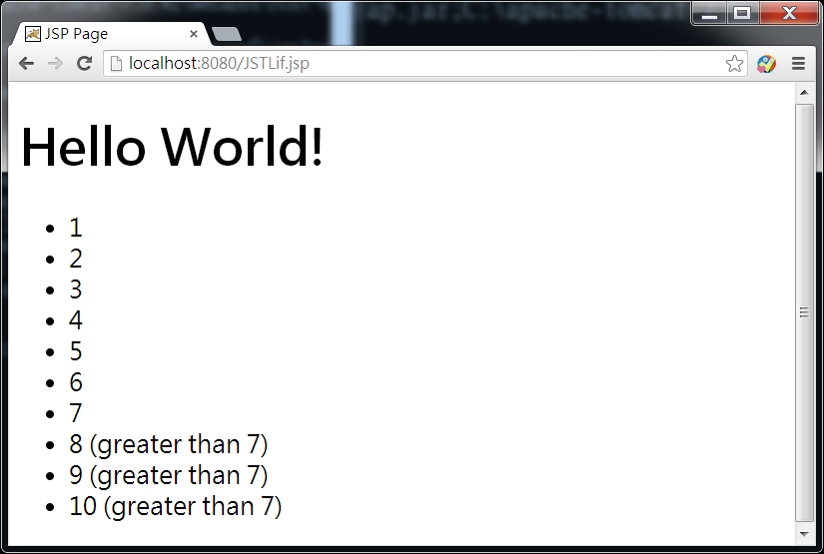
NetBeans製作Tomcat基本JSTL Tags
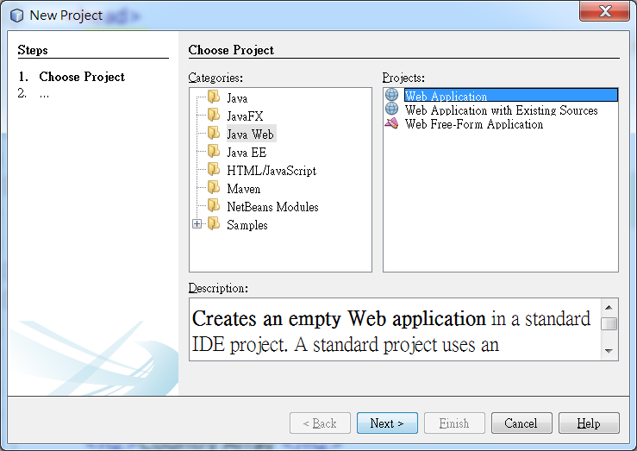
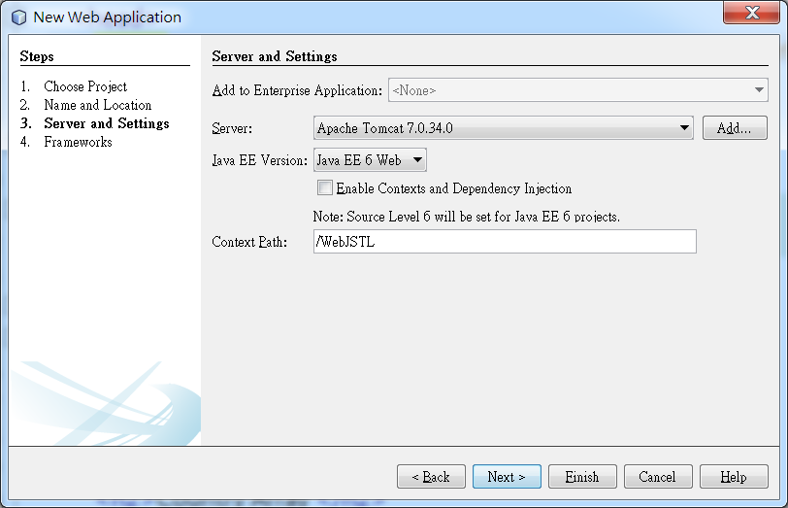
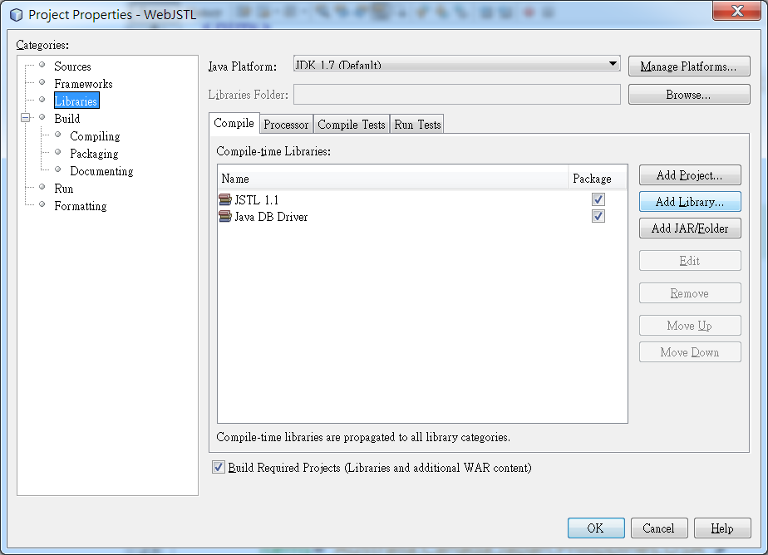
將上述的幾支程式直接加入到web pages內
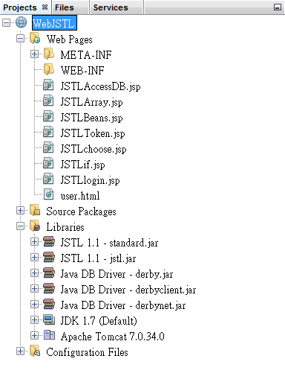
最後直接執行.jsp的程式

